Manual coding instructions for Excel

* Learned steps, reverse learned steps and open steps need to be manually coded
* Learned steps will be counted as steps in the forward direction, I.e. towards the dotted end of the guided purple line (Point A in red to point B in red; figure 1)
  + The purple line will always begin in the top right corner and loop around, ending just to the left of the beginning point
  + Direction (forward or reverse) is relative to the starting point in each specific map
* Data from participants, which is coded on maps with a black line, will be interpreted from green starting point to red ending point (Read point C to point D in figure 1)
* If the line does not reach the red ending point (D), the steps must still be counted as is
* Any box where the black line crosses, going towards the dotted end of the guiding purple path will be counted as learned steps
* Any box where the black line crosses, going towards the beginning point of the guiding purple path are counted as reverse learned steps
* Any box where the black line crosses that does not have a purple line in it, will be counted as open steps
  + This includes yellow path only, and no path/empty box
    - In figure 2, Point X and Y are examples of these cases
      * For point X, purple path would take preference in counting
* In the case of a participant turning around in the study, where the black line makes a loop or changes direction, the box in which they turn around in will only be counted once, based on the direction it was entered
  + Overlapping boxes would then be counted again based on the opposite direction

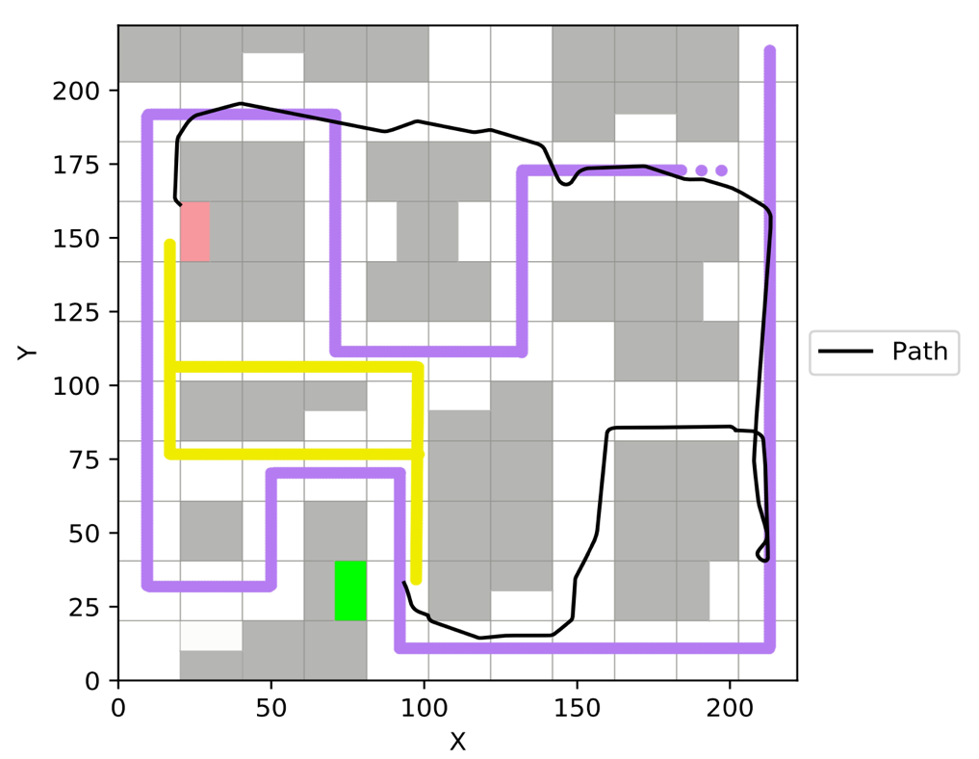

1

2

3

A

B

C

D

In figure 1, beginning at the green box, the black line is going in the reverse learned direction. At the box labelled 1, the participant started going in the learned step direction. Labelled boxes 1,2,3 would be counted as learned steps. Box 3 was the box in which the participant turned around, but since they entered from the learned direction, it will only be counted as such. Going back, boxes 2 and 1 would then be counted in the reverse learned direction (I.e. they are double counted), and counting continues as normal for all boxes entered once

Figure 1

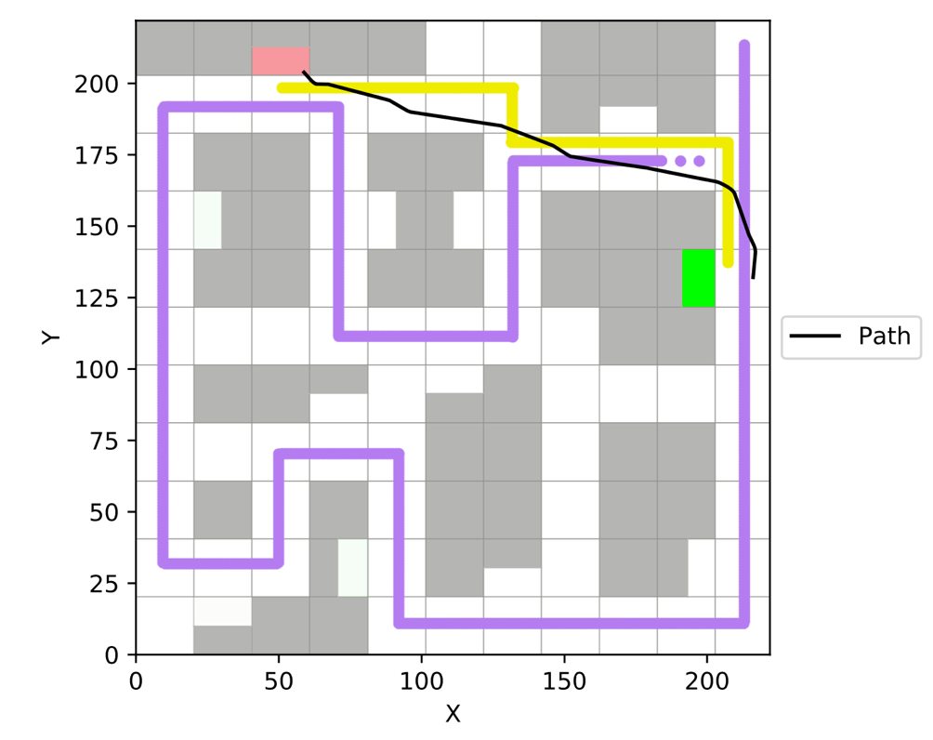

X

Y

Figure 2